

**Lesson 3: Main Circle Commands**

**Summary:**

|  |  |
| --- | --- |
| **Code Instruction** | **What it does** |
| **t.circle(radius)** | **Draw a circle with the given radius value. Radius value can be positive or negative, depends on the direction of the turtle motion.** |
| **t.circle(radius, arc)** | **Arc option allows to draw part of the circle. If arc=360 turtle draws all 360 degree circle, if arc=180, turtle draws half of the circle, if arc=90🡪 quarter of the circle. Arc value can be positive or negative, depends on the motion direction.** |
| **t.circle(radius, arc, steps)** | **With option steps (integer value) circle is approximated by an** inscribed regular polygon, steps determine the number of steps to use. May be used to draw regular polygons. Step=3 means that we draw triangle, step=4 corresponds square, step=5🡪pentagon… |

**A few tips:**

1. A **circle** is a shape that is made up of a curved line. It's round, and all points on the curved line are an equal distance from the centre­­­ point. The circumference is the distance around a circle

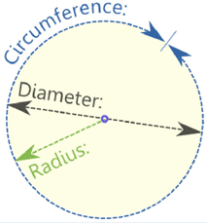

1. The arc of a circle is a portion of the circumference of a circle specified by yellow colour.

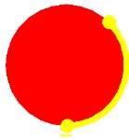

Arc value is measured in degrees and if **arc=360 turtle draws all 360 degree circle, if arc=180, turtle draws half of the circle, if , for example, arc=90🡪 quarter of the circle. Arc value can be positive or negative, depends on the motion direction.**

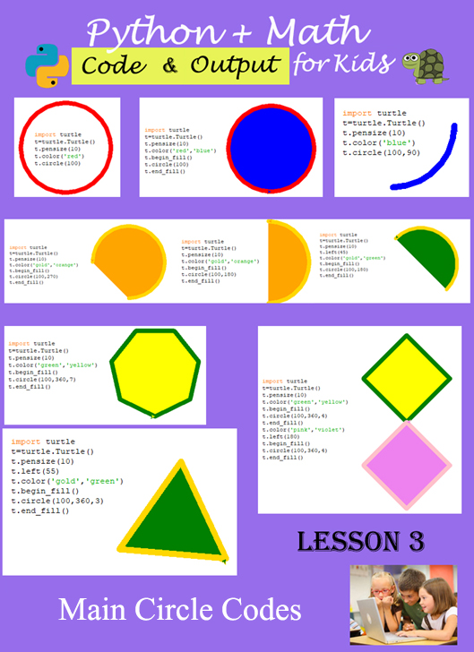

1. **Example #1** (Draw circle)

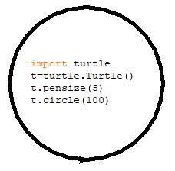

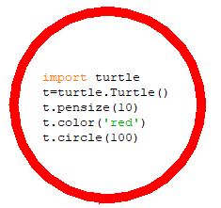

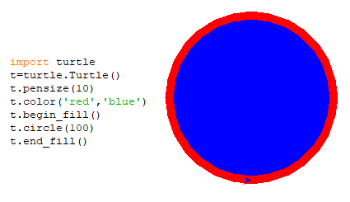

1. **Example #2** (Draw part of the circle). We use arc option

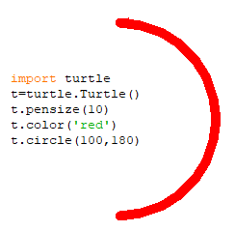

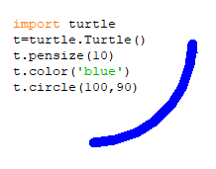

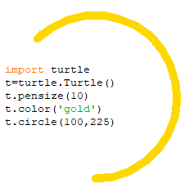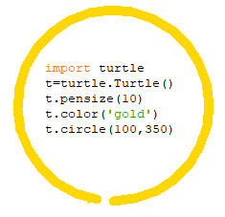

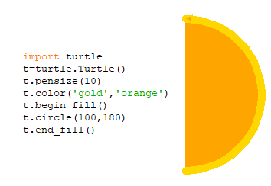

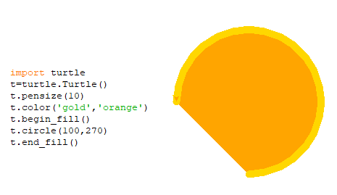

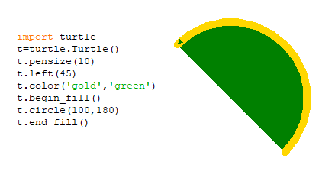

All images from Example #3 are drawn with **circle** code (turtle can draw different polygons as triangle, square, pentagon, hexagon…). To create it we use an option step, specified in summary. Again code **circle(radius, arc, steps) has three options: option 1🡪radius value; option 2🡪arc value; option 3🡪 step value. I you use only option 1, turtle draws full circle with radius specified by radius value; if you use two options (option 1 and 2) turtle draws part of the circle; and when you use tree options (first radius value, second 360-degree value, and third option 3, or 4, or 5 or 6….) turtle draws polygon instead of circle.**

1. **Example #3**(Draw inscribed into the circle regular polygon).

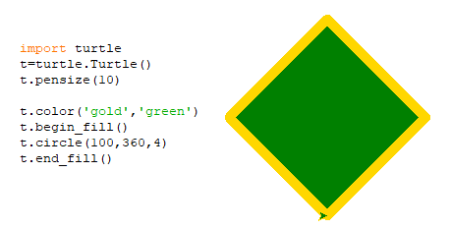

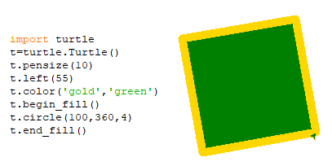

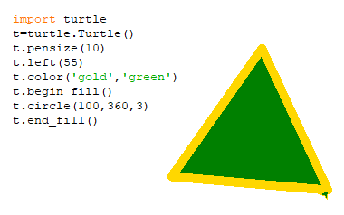

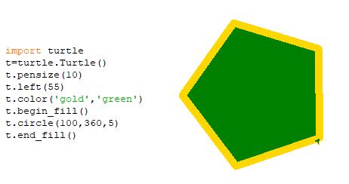

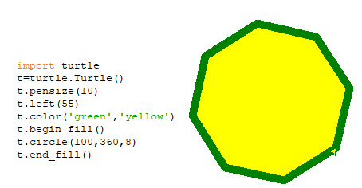

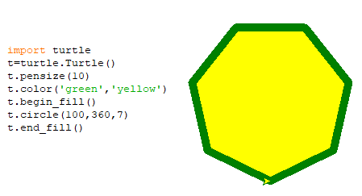

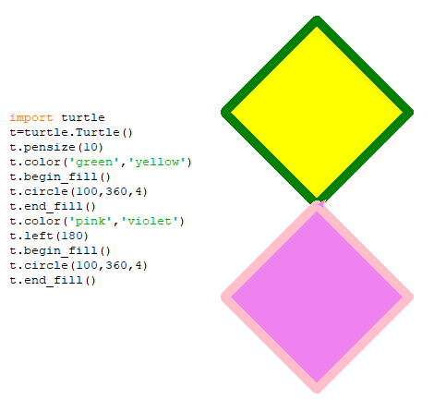

1. **Example #4** (Olympic flag)

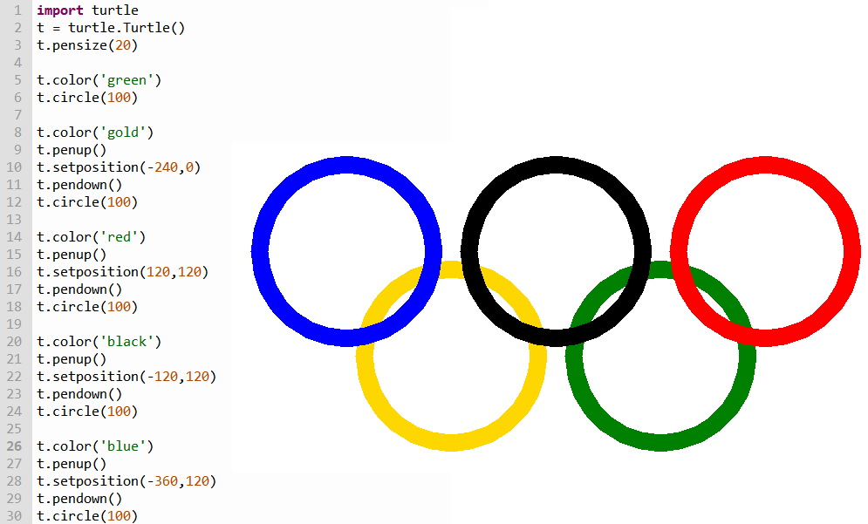

1. **Example #5** (Rainbow)

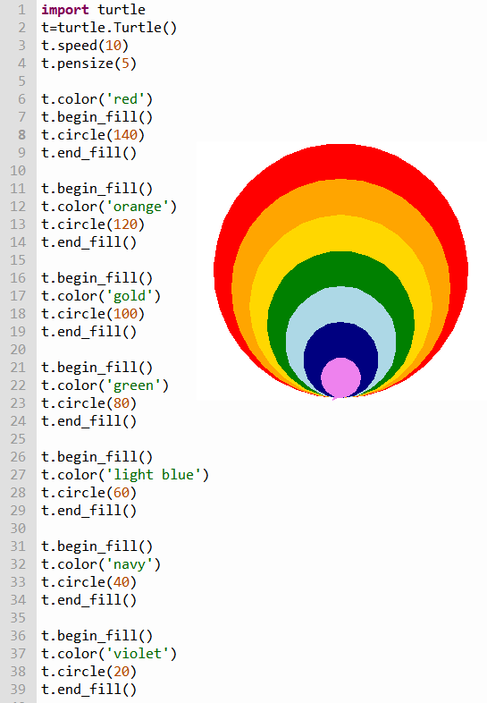

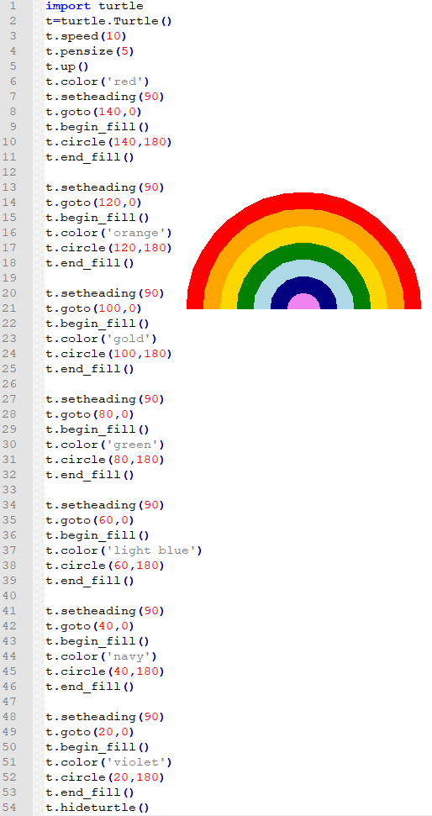

Challenges: write codes to create the following geometry shapes with circle code:

1. Expected output

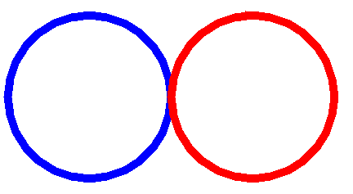

1. Expected output

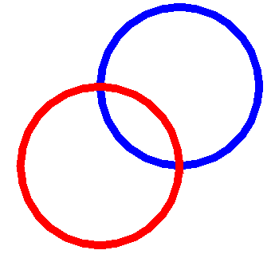

1. Expected output

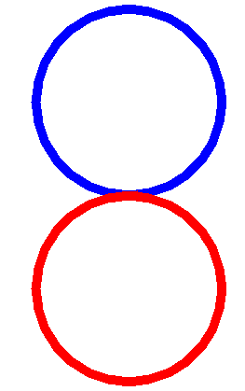

1. Expected output

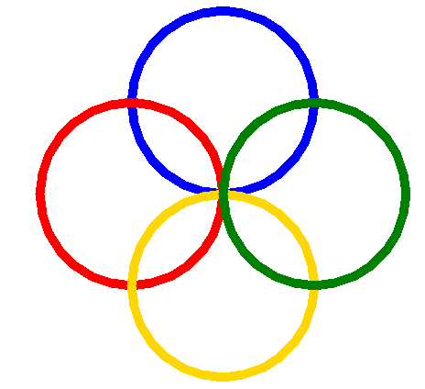

1. Expected output

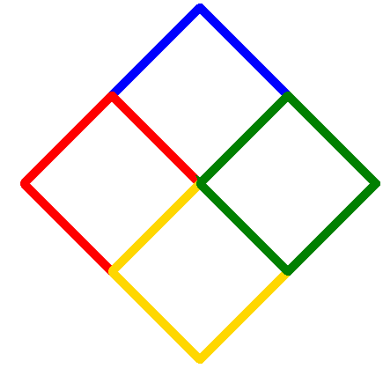

1. Expected output

